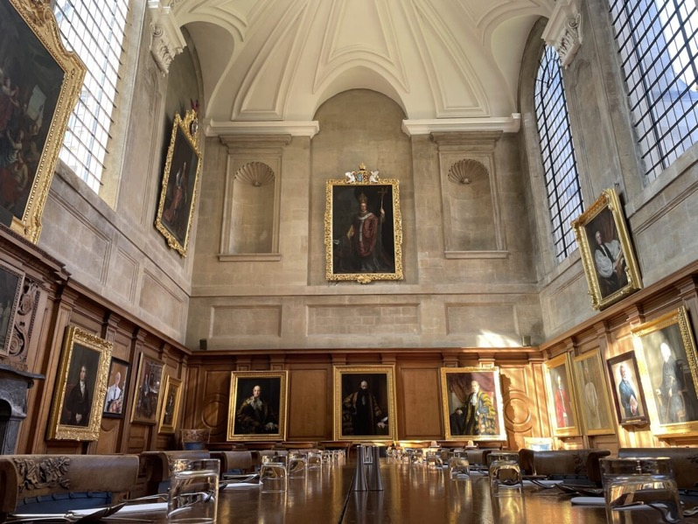

Sennheiser SpeechLine Digital Wireless restores usability to All Souls College’s remarkable 15th century meeting room
Strong industry relationships between CAV Oxford, Leisuretec, and Sennheiser ensure best possible outcome for prestigious client

Marlow, April 30, 2024 – Sennheiser, the first choice for advanced audio technology that makes collaboration and learning easier, is proud to have its SpeechLine Digital Wireless (SLDW) microphone system selected by the prestigious All Souls College to enhance audio in one of the college’s oldest, most unique meeting rooms.

Founded in 1430 by Henry VI, All Souls College is a constituent college of the University of Oxford in England, UK. With an almost 800-year history, the aim for the college was to enhance one of their most historic rooms with a high-quality audio system. Renowned for its speech applications and user-friendly setup, SLDW was the choice to help future-proof one of Britain’s top academic research institutions.

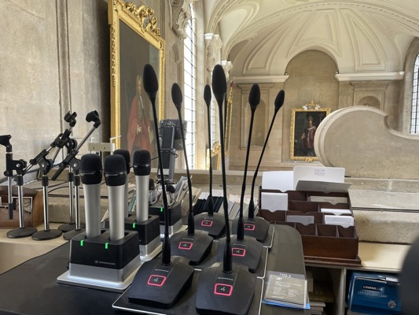 | Sennheiser SLDW is developed with the end user in mind and designed for university and corporate use, making it a perfect solution for All Souls College

Describing their initial acoustical challenges, Paul Blaxill, Director of IT at All Souls College, explains that their primary issue revolved around the building’s extraordinary architecture, with many rooms boasting vaulted, intricately carved stone ceilings. “Using these beautiful, ancient rooms for modern purposes required adaptation, which prompted us to reach out to local hire company CAV Oxford,” he explains.

CAV provides tailored support to many of Oxford’s most prestigious venues. When All Souls College asked them for help, the team knew that SLDW was the right solution. The primary driving factors were the system's user-friendliness for easy operatation for non-technical personnel, and its range of built-in features that eliminate the need for additional outboard equipment.

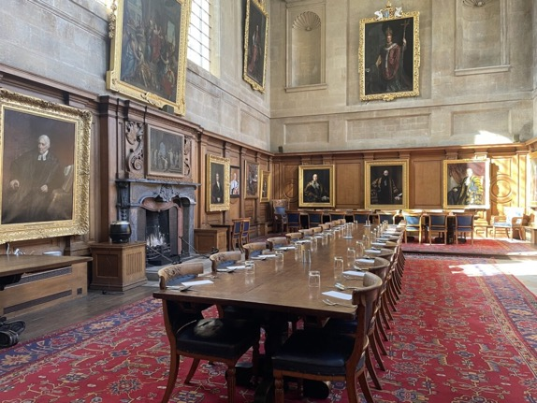 | Strong industry relationships between CAV Oxford, Leisuretec, and Sennheiser ensure best possible outcome for prestigious client

Leisuretec, an experienced and trusted Sennheiser distributor since 1990, was chosen to deliver the system because of its long-standing relationship with the global audio manufacturer.

Knowing that technical support would not always be readily available in the College’s meeting room, Leisuretec understood the installation needed to be perfect and remain consistent over time. This was the reason why Obed Mashayamombe, Glenn Smith, and Clover Richards, all part of Leisuretec’s sales team, took CAV’s Director, Sam Haney, for a training day at Sennheiser UK. There, they met with the company’s Business Development Manager, Kevin Gwyther-Brown, Gareth Peters, Inside Sales Support, and Eddie Lane, Channel Sales Manager, who ensured that both CAV and Leisuretec were inducted into the finer details of SLDW.

Mashayamombe explains that visiting Sennheiser was key to achieving a better overview of the possible outcomes.

“Leisuretec have been supplying Sennheiser equipment for well over 20 years and enjoy a great relationship with the company,” he says. “The team are always on hand and ready to help us with technical questions, sales queries, and even with our marketing assets. Any member of our team knows they can contact Sennheiser and receive high-quality support, as demonstrated with the invitation for us and our customer to visit their UK headquarters in Marlow to ensure the correct equipment was supplied for the job at hand.”

Gwyther-Brown notes how close relationships like these endure, and what the team at Sennheiser do to support its clients.

“Leisuretec is a well established UK distributor for Sennheiser, and we’ve enjoyed a long-standing relationship with them,” he notes. “We know the support we give Leisuretec will be really beneficial, not just to them but to their clients. This is what keeps them coming back to us, and it’s not just the business development team, but all the help from Sennheiser’s associate staff, like tech support, training, and account management. Supporting our distributors allows us to have better relationships with our end users, and that’s what Sennheiser is all about.”

Sennheiser SLDW is developed with the end user in mind and designed for university and corporate use, making it a perfect solution for All Souls College. A streamlined end user experience is improved by integrated DSP, providing EQ and automatic audio level management. This means that fellows can concentrate on their discussions without distraction.
Sennheiser SLDW is developed with the end user in mind and designed for university and corporate use, making it a perfect solution for All Souls College | 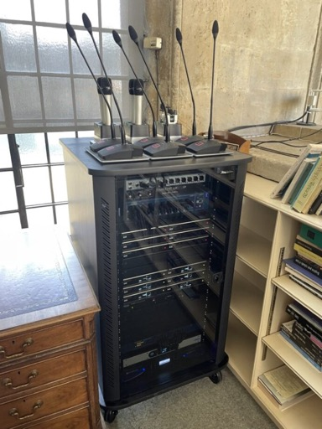

The SLDW system works with simple single button operation. Additionally, docking stations for charging have been mounted in a glass fronted rack unit, with speakers blending seamlessly into the room with a custom paint job. The easily accessible charging stations mean equipment is always ready for use and can last all day thanks to the 15 hour battery life.

The team at All Souls College are completely satisfied with the results of the intallation. A previously unusable but beautiful room has now become an inspiring place to meet and discuss. It has been an instant success, as Haney confirms.

"The quality that Sennheiser SpeechLine Digital Wireless has provided has been met with delight,” he says. “That’s why Sennheiser and Leisuretec are CAV’s preferred suppliers for audio installations.”

Blaxhill agrees and is happy to remark on the successful outcome. “The overall audio quality was a massive leap forward,” he reports. “CAV Oxford understood the brief and designed a system that exceeded our requirements. They were incredibly professional, and the rack containing all the equipment was beautifully presented; it’s a work of art.”

Relationships are more important than ever in the pro-audio industry, and Sennheiser understands this, especially with longstanding partners like Leisuretec.

“We always try to go above and beyond for our clients,” concludes Gwyther-Brown. “We love to meet the teams and share knowledge. The successful collaboration between all concerned highlights the importance of understanding client needs and utilising innovative solutions in audio technology. We’re here to engage with our clients and our distributors. Support is a massive part of our remit, and we love it!”

[The End]

About the Sennheiser Group

Building the future of audio and creating unique sound experiences for our customers - this is the aspiration that unites the employees of the Sennheiser Group worldwide. The independent family-owned company Sennheiser was founded in 1945. Today, it is managed in the third generation by Dr. Andreas Sennheiser and Daniel Sennheiser and is one of the leading manufacturers in the field of professional audio technology.

sennheiser.com | neumann.com | dear-reality.com | merging.com

Local Press Contact
Sennheiser electronic GmbH & Co. KG
Maik Robbe
Communications Manager EMEA
T +49 (0) 5130 / 600 1028
Maik.Robbe@sennheiser.com

